

Antenna Alignment Augmented Reality Video Application

Final Year Project

Chris cornwall -12311016

15/04/2018

Contents

[Introduction 2](#_Toc510611998)

[Alignment of Highly Directional Microwave Antennas 2](#_Toc510611999)

[Augmented Reality 2](#_Toc510612000)

[Description 2](#_Toc510612001)

[Literature Review 3](#_Toc510612002)

[State of the Art Review 8](#_Toc510612003)

[Java 8](#_Toc510612004)

[Javascript 8](#_Toc510612005)

[HTML 5 8](#_Toc510612006)

[jQuery 8](#_Toc510612007)

[PHP 9](#_Toc510612008)

[MySQL 9](#_Toc510612009)

[Wikitude SDK 9](#_Toc510612010)

[Design 10](#_Toc510612011)

[Implementation 12](#_Toc510612012)

[Nativedetailscreen.js 13](#_Toc510612013)

[Marker.js 14](#_Toc510612014)

[Signal.js 15](#_Toc510612015)

[Radar.js 16](#_Toc510612016)

[Backend 16](#_Toc510612017)

[Evaluation 17](#_Toc510612018)

[Additional Requirements 19](#_Toc510612019)

[Conclusion 23](#_Toc510612020)

[The AREA Framework for Location-Based Smart Mobile Augmented Reality Applications - Rüdiger Pryss\*, Philip Geiger, Marc Schickler, Johannes Schobel, Manfred Reichert 23](#_Toc510612021)

[Navigation in Augmented Reality : AN EXPERIMENTAL STUDY COMPARING NAVIGATION IN AUGMENTED REALITY AGAINST ONLINE STANDARDIZED MAPS - SARAH BERNELIND 23](#_Toc510612022)

[Works Cited 24](#_Toc510612023)

# Introduction

In recent years, there has been a steady growth of wireless infrastructure across the globe (Grand View Research, 2018), fixed wireless is now an attractive solution to many businesses and homeowners, who, in previous years, may have had difficulty obtaining and maintaining a quality broadband connection.

To achieve these high speed fixed wireless connections, a radio signal is sent from a transmitter antenna to a receiver antenna via highly directional microwave antennas. As the name suggests, these antennas are highly directional, meaning that the signal they transmit and receive performs well over relatively large distances. However, as a side effect of this increased directional power, they must be aligned in both the horizontal and vertical plane to a high degree of accuracy in order for the receiving antenna to obtain an adequate signal.

Typically, when an ISP technician installs a highly directional microwave antenna, they use a specialist piece of equipment, commonly referred to as a spectrum analyser, to read real-time signal data. Whilst this real-time information can be used to correctly align the antenna in both the horizontal and vertical planes, it does require some trial and error initially so that the antenna can be aligned in the correct general direction.

Currently, this initial trial and error phase cannot be avoided as there is no solution in today’s market which caters for the initial alignment of wireless link antennas. However, there are a number of solutions on the market which aid with the alignment of terrestrial satellites, such as Satfinder and Satfinder 3D. As the alignment of these satellites is similar to the alignment of wireless link antennas, many of these applications could be easily adopted to fit such a purpose.

# Project Description

“Antenna Alignment Augmented Reality Video Application (Smartphone or Drone derived Video). The goal is to develop a novel smartphone application that uses augmented reality techniques to help with the alignment of highly directional microwave dish antennas. High speed fixed wireless point to point links use very high gain and directional dish type antennas that have often had a very narrow beamwidth so precise alignment in both the horizontal and vertical planes can be very difficult, especially when working at height on a telecoms tower or rooftop. The application would be used to provide visual clues to help engineers with the initial alignment of the antenna as well as information on the expected signal strength based on the distance and power budget calculations. The video source could be the camera on a mobile phone or video being streamed live from a GPS enabled drone.”

# Literature Review

In an effort to conduct the relevant research for this project I identified the following areas as being particular areas of interest:

• Development of an augmented reality android application using an appropriate SDK

• Using sensor data gathered from a smartphone to accurately predict a user’s location

• Basic wireless link budget analysis

For my preliminary research, I first asked the question “what is augmented reality?”. The answer to this question being that AR allows for combining or “supplementing” real world objects with virtual objects or superimposed information. As a result virtual objects seem to coexist in the same space with the real world (Azuma et al., 2001). Following on from this, the next question I asked was “what level of maturity and adoption is augmented reality currently at?”. To this end, I have consulted Gartner’s Hype cycle (Gartner, 2017) , which of July 2017, concludes that AR will reach the plateau of productivity in the next 5 – 10 years.

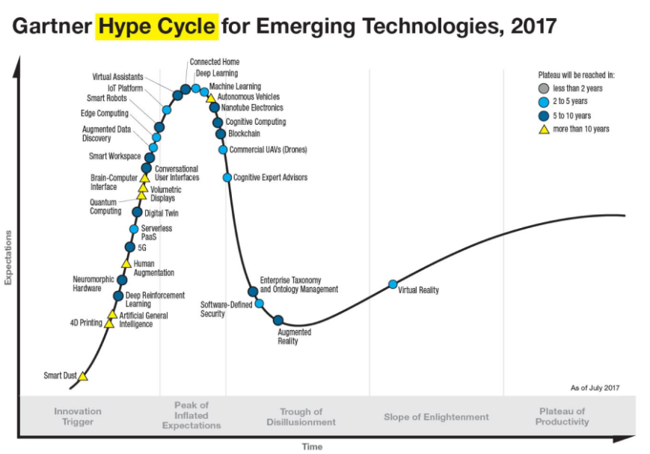

With this being the case, although development of augmented reality technologies is currently in the “trough of disillusionment”, the future looks promising as we are close to entering the “slope of enlightenment”.

Whilst augmented reality’s place in the gaming world was very much solidified by the success of Pokemon Go, applications of AR in other areas such as tourism and engineering, have yet to have the same impact. This leads to the question “how applicable is AR in these areas? “. Specifically, because this project’s goal is to apply AR in the realm of engineering but to do so using AR techniques more frequently used in the realm of tourism (i.e. location based AR). What are the benefits to using AR in tourism and engineering, if any? (Bernelind, 2015) conducted an experiment in which users were given the task of navigating a route using augmented reality navigation for one run and using Google maps for another. The goal was to ascertain which method would be more effective in this scenario. Although the results indicated that users preferred Google maps, the metrics used to determine this result and the observations made in coming to this conclusion are of note whilst contemplating the design of any location based augmented reality application.

To gain a better understanding of why users ranked Google maps with a higher overall usability than the augmented reality alternative, we must first look at the requirements on which to base the statement of usability set out in this paper – user satisfaction, efficiency, effectivity, learnability. When asked questions directly relating to each of these requirements, users indicated that their experience with Google maps was superior for a number of reasons including: lack of continuous feedback in the AR application, a feeling of “surreptitiously filming people in front” of a user and unstable markers. As this project will be used in a technical environment, the feeling of “surreptitiously filming” does not pose an issue, but the points made about continuous feedback and unstable markers are most certainly of note.

Having completed the preliminary research, I concluded that the most challenging aspect of this project was going to be the work relating to augmented reality. In particular, accurately displaying the position and orientation of an antenna, or indeed any object, presents a non-trivial technical challenge which requires the manipulation of mobile sensor, camera and GPS data. With this in mind, I conducted the remainder of my research with an emphasis on the implementation of augmented reality applications and with an aim to uncover the methodologies behind developing a highly accurate and user-friendly augmented reality application.

In order to successfully develop an augmented reality application it is important to obtain an understanding of how the kernel of such an application may operate. (Pryss et al., 2017) describe the design and implementation of such a kernel.

In “The AREA Framework for Location-Based Smart Mobile Augmented

Reality Applications”, the design and implementation of a mobile augmented reality kernel known as AREA v2 (Augmented Reality Engine Application version 2) is described in great detail, alongside the challenges faced whilst implementing such a kernel and the solutions which were found.

AREA v2 is a location-based augmented reality kernel, which, like any other augmented reality application, faces domain specific challenges, namely: overlapping points of interest, OS-specific sensor data processing and the reliable display of points of interest markers.

The problem of overlapping points of interest is a common theme amongst many research papers (including (Bernelind, 2015)) on the topic of location-based augmented reality. Many of these papers suggest their own novel solutions to this problem, and (Pryss et. al., 2017) is no different. In it, the authors suggest using a clustering algorithm which takes preferences from the user and then clusters points of interest, based on these preferences, into one point which is represented by a marker on the screen. This marker can then be used as a gateway to the POIs contained within it, thus enabling the user to interact with POIs that may previously have been hidden.

With regard to OS-specific sensor data processing with an aim to providing accurate and reliable POI markers, this paper notes that “regarding iOS, sensor data of the gyroscope as well as the accelerometer are used, whereas for Android sensor data of the gyroscope, accelerometer and compass of the mobile device are used to position the virtual 3D camera correctly.” Whilst these nuances are naturally handled by any augmented reality SDK and are not necessarily present in every augmented reality engine, it is important to note this difference, as performance of an application may change based on the operating system and set of circumstances at play.

Following on from this, the paper delves into issues involving “jittery” POI markers and possible sources of interference. The authors note “when using (a) the values of the gyroscope for a user that (b) frequently changes the position of his Android smart mobile device, the POIs on the screen of his smart mobile device oscillate badly. To obtain better user experience, we smooth the gyroscope values by using the SLERP algorithm [16] (cf. Algorithm 1, Line 28). Second, the rotation vector provided by the Android mobile OS is very precise on one hand, but it is prone to (1) frequent position changes, (2) slow position changes, and (3) magnetic interference sources on the other”. [Pryss et al]. Again, with this issue, some of the above may be handled by the chosen augmented reality SDK but it is nonetheless important to take note of this so as to enable swift identification of such issues throughout the development process.

Having conducted a substantial amount of research in the area of AR, the next most relevant research relating to this project is that of a basic link budget analysis. Principally, the calculation of the signal to noise ratio which will be used to give the user an estimate of the expected power at a given receiver must be calculated. To identify the correct formulae for these calculations I have consulted the Maxim Integrated webpage (Maxim, 2011). Maxim Integrated are a fortune 1000 company specialising in analogue and mixed-signal integrated circuits (Wikipedia, 2008). Their webpage offers a brief description of each of the following formulae and an accompanying spreadsheet which, in relation to this project, is very useful from a testing perspective.

**Wavelength**

*= c/*

**Effective Isotropic Radiated Power**

*EIRP =*

**Free Space Path Loss (dB)**

*FSPL (dB)*

**RX Power Free Space Path**

*= + - (C&C Loss)*

**Noise Power (at RX)**

*= k ( + )*

**Signal to Noise Ratio**

= /

**Where:**

* f = frequency of transmitter
* *(C&C Loss)* = cable & connection losses
* *k =* Boltzmann's constant ()
* = antenna temperature
* = effective temperature
* = receiving bandwidth
* = power at receiver
* c = speed of light (≈299792458 m/s)
* = power at transmitter
* = gain at transmitter
* = wavelength
* = distance between receiver and antenna
* = power at RX antenna, free space path
* = Gain at receiver

# State of the Art Review

Many technologies have been used throughout this project. Aside from the main programming languages which were used to create the application (Java, Javascript and HTML 5), other common technologies such as jQuery, PHP and MySQL were used alongside a less well-known technology – Wikitude SDK. Please see below for a brief summary of each of these technologies alongside an explanation of how they were applied to create this project.

## Java

Java is a “general-purpose, concurrent, strongly typed, class-based object-oriented language” (Oracle, 2018). It is commonly used across a range of applications and is also the native language for Android applications. For this project, I have used Java to retrieve and manipulate sensor and GPS data which is then passed to the Wikitude SDK (more on this below).

## JavaScript

JavaScript is a highly dynamic, interpreted programming language which is mainly used in conjunction with HTML. In this project, I have used JavaScript for the creation and handling of AR objects along with the overall management of the GUI.

## HTML 5

HTML 5, or Hypertext MarkUp Language is the standard markup language used in webpages across the globe. In relation to my project, HTML was used to render the GUI, which was then manipulated using Javascript as mentioned above.

## jQuery

jQuery is a Javascript library which can be used to simplify the styling and animation of HTML pages. For this project, I used jQuery to create the basic style of the app and also to handle some of the GUI animation.

## PHP

“PHP (recursive acronym for *PHP: Hypertext Preprocessor*) is a widely-used open source general-purpose scripting language that is especially suited for web development and can be embedded into HTML.” (php.net, 2018). In this project, PHP was used in conjunction with MySQL to allow a user to add to, edit or delete from the antenna database.

## MySQL

MySQL is a relational database management system which is open-source and widely used. For the purpose of this project I decided to use MySQL to store the locations and properties of each transmitting antenna.

## Wikitude SDK

The Wikitude SDK is a cross-platform, mobile augmented-reality SDK which offers many different forms of augmented-reality such as geo-tagging, image-tracking and location-based AR (Wikitude, 2018). Wikitude is available as a plugin for many platforms including Unity and Cordova and its Javascript API can be used within Android Studio to develop augmented reality apps for Android. Alongside an abundance of features, Wikitude provides a vast amount of documentation which has proved invaluable throughout the implementation of this project and which is one of the core reasons why I chose to use Wikitude instead of other SDKs such as ARmedia.

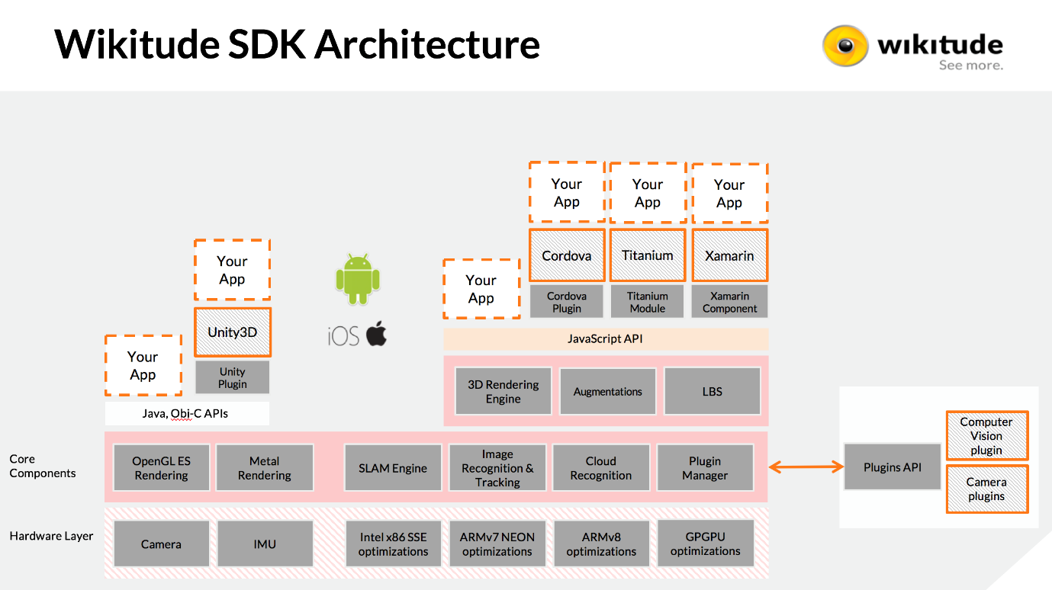

# Design

The design phase of any application can be challenging but it is particularly challenging in the realm of location-based augmented reality. This extra layer of complexity is present in location-based augmented reality applications because of the issue of overlapping POIs as mentioned in the literature review above. Overcoming this challenge and ensuring a high level of usability were my main priorities during the design phase of this project. The following diagrams (fig. x, fig x1….) show my original design:

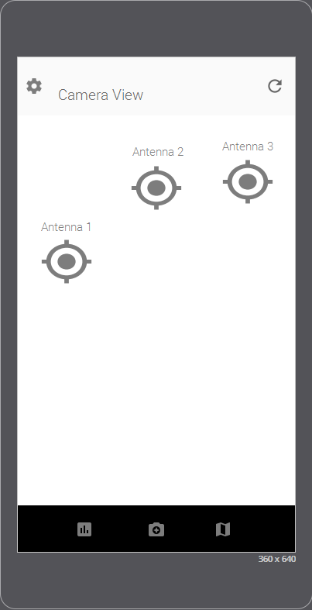 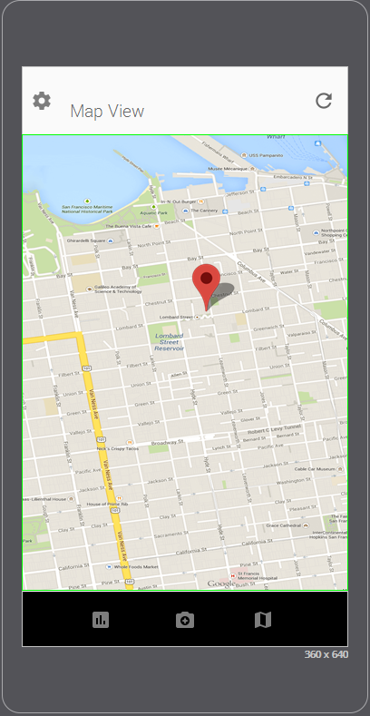 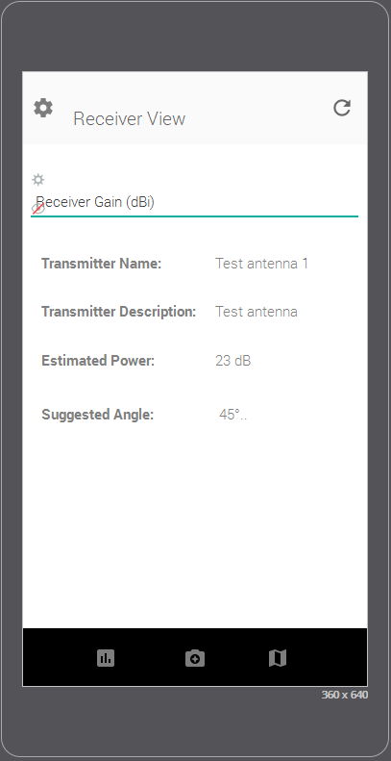 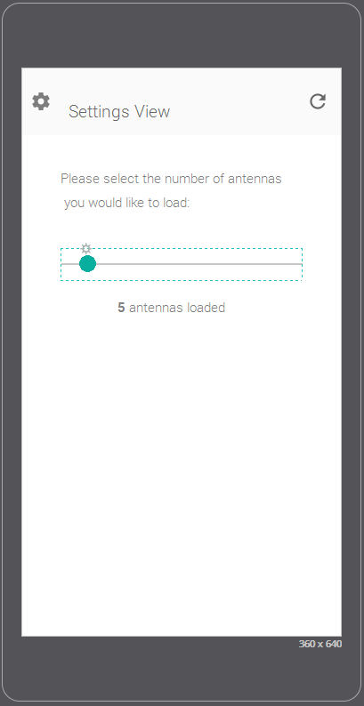

This design is simplistic and very user-friendly as it contains only 4 screens, each of which can be navigated to using one of the three buttons found along the action bar at the bottom and the settings icon located in the top left corner. To reload the antenna markers on the screen, the refresh symbol placed in the top right corner of the screen can be pressed. This is all very intuitive which, of course, is the aim. However, after more consideration, I concluded that four completely different screens were unnecessary and that the above design could be condensed into one screen with multiple overlays partially, or fully covering the camera view, as needs be.

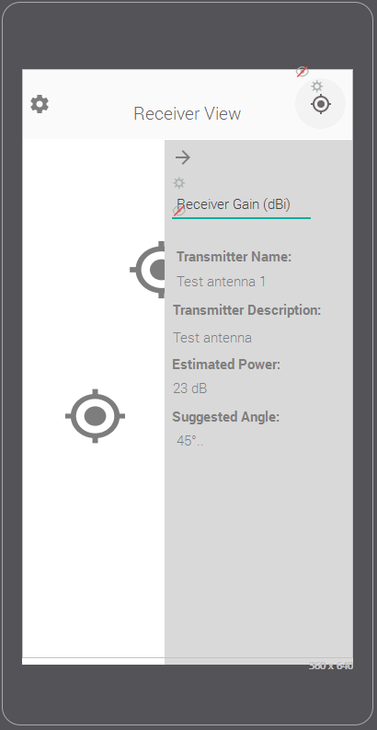 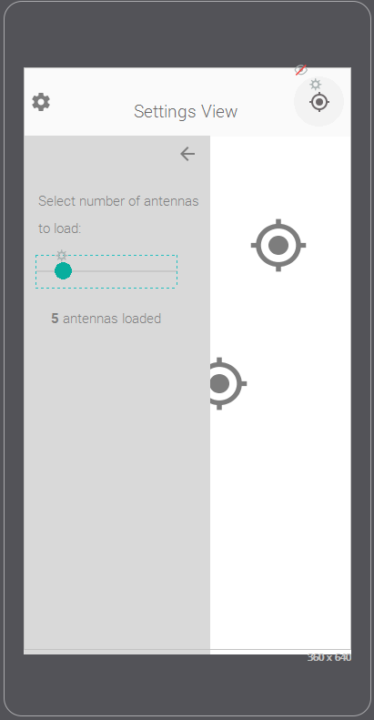

With this new design, users can input and see signal data simply by clicking on a desired marker, which will display an overlay where data can be input/viewed. Similarly, a user can click the gear icon to display an overlay where the number of antennas loaded to the screen can be adjusted. The map view remains much the same in this design, but is accessed through the location icon on the top right of the screen which then displays a map overlay, covering the entire screen. In an effort to simplify the design, I have decided to remove the reload button and instead, let any click on the screen which is not on a button or marker cause a reload to happen.

# Implementation

Align AR is an android application with a core, written in Java, that uses the Wikitude Javascript API to render augmented reality geo-objects to the screen.

In “MainActivity.java” the basis of the app is created, on which everything else is built. Within “MainActivity.java” an “architectView” is created. This architectView is part of the Wikitude Javascript API and is used to create a camera surface and to handle all sensor events (REF:<https://www.wikitude.com/external/doc/documentation/latest/android/setupguideandroid.html>).

Originally, I began using Unity to develop this project as it offers a whole host of UI features which are particularly suited to this type of application. Naturally, before beginning any development, I ensured that Wikitude supported a Unity plugin, however, I later found out that this plugin has limited functionality and does not support Wikitude’s location based augmented reality features. Because of this I was forced to decide between using Unity with a different AR SDK or to revert to Android Studio and continue using the Wikitude plugin. After analysing the other AR SDK alternatives, I decided to revert to Android Studio and continue using Wikitude. In the end, this decision was a relatively simple one as Wikitude’s location-based AR seems far more mature than other offerings and as their documentation is second to none.

Another major change which I made early on in the development process is the use of Google Play Services “fusedLocationProvider”. The “fusedLocationProvider” is used to obtain a user’s current location which is then passed to the architectView as latitude, longitude and elevation (along with accuracy). Originally I used Android’s own location service to facilitate this functionality but after experiencing significant inaccuracies and very poor power usage statistics I decided to switch to Google’s fused location provider which has proved to be far more accurate and efficient. This improved performance is well documented (REF: Include play services vs android location reference). Apart from gathering sensor data and creating the main activity, the Java code itself provides no functionality to the user. The entire front-end experience is built in Javascript and html, in what is commonly referred to as, the “ARchitect World”. Please see below for a complete end-to-end flow of how each component in the application interacts with each other:

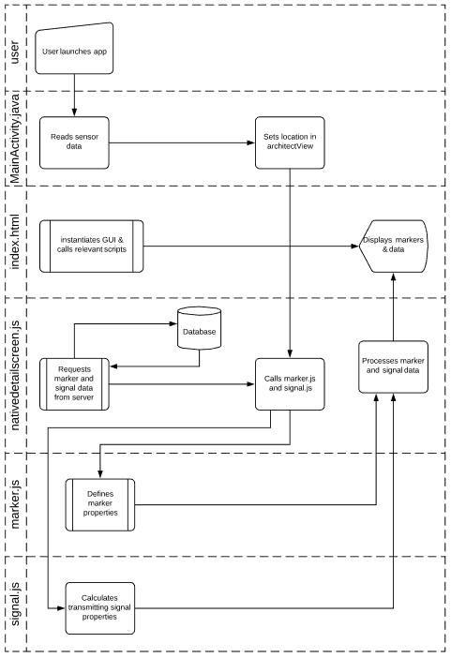

My ARchitect World is closely modelled off of the Wikitude example which can be found here (REF: INCLUDE LINK TO SAMPLE). In the example, the GUI is built in HTML and is manipulated using Javascript. Likewise, Align Ar is built using the same technique, but with a number of extra features as will be described below.

In “index.html”, a transparent html page is created over the camera view using jQuery’s “mobile-transparent-ui-overlay.css”. From this starting point, each Javascript file is loaded, a breakdown of the core functionality of each of these is as follows:

### Nativedetailscreen.js

Most of the front end display and user interaction is handled in “nativedetailscreen.js”, while specific marker, radar and signal properties/functionality are handled in their own scripts. In this script, a “world” variable is created which defines the AR world and the functions that control it. These functions directly influence the gui as seen by the user and include functionality to update the values of markers as users move between locations, change the amount of markers being displayed based on a user’s preference and handle the gui elements as panels are opened and closed. Some of the other functionality provided in “nativedetailscreen.js” is as follows:

#### loadPoisFromJsonData

As the name suggests, this function loads POIs (points of interest a.k.a antennas) from a json file stored on the danu6 server. Each POI contains information about a given antenna, including their latitude, longitude and elevation. Using these details, a new marker is created and added to the world’s marker list.

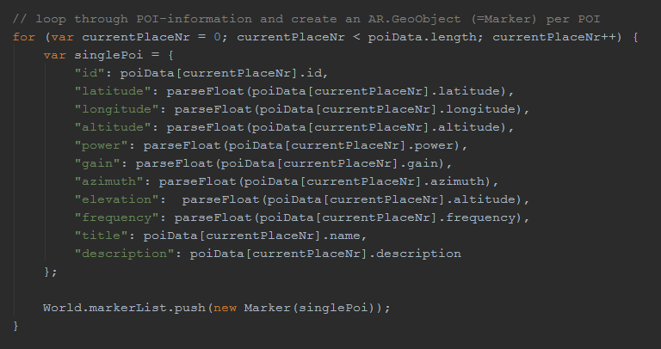

#### HideMarkers

This function is called when a user clicks on a marker and is used to hide all the other markers currently visible on the screen. In doing so, this prevents too much “clutter” from appearing on the screen and also helps to ensure that a user is not accidentally looking at the wrong marker.

#### InitMap & InitMapMarkers

These functions are used to initialize the Google Maps API and to place the antenna locations as markers on these maps.

### Marker.js

“marker.js” defines the properties and functionality of each individual marker. This includes the initial creation of the geo-object, the animations of the image drawables (including idle, active, green etc..) and the on-click triggers.

### Signal.js

The “signal.js” script is where all the necessary calculations are performed in order to calculate a number of properties for each signal being transmitted. A breakdown of the main functionality of signal.js is as follows:

#### Link Budget Analysis

To calculate the link budget between the receiver and transmitter, signal.js reads the power (dBm), frequency (MHz) and gain (dBi) of the transmitter and perform a link budget analysis using the formulae described in the literature review above. It is important to note, that while the formulae used in this implementation are the same as the formulae above, unit conversion is also taking place and thus the formulae are modified to accommodate this.

1. **var**
2. poiData = poiData;
3. distance = distance;
4. angle = getAngle(poiData, distance);
6. // Transmitter Frequency, power and gain all grabbed from input json
7. frequency = poiData.frequency \* 1000; // MHz
8. tPower = poiData.power; // dBm
9. tGain = poiData.gain; // dBi
10. lightSpeed = 299792458; // m/s
11. wavelength = lightSpeed/(frequency\*1000000); // m

14. // Free space path loss
15. fspl = 20\*Math.log10((wavelength/(4\*Math.PI\*distance))); //dB
17. // Effective isotropic radiated power
18. eirp = tPower + tGain; //dBm
20. // Power at Receiver
21. powerAtRec = eirp + fspl; //dB

24. // Plus gains and losses
25. rxPowerFSPL = powerAtRec + rxRecGain + rxConLoss + rxCableLoss;
27. // Noise at RX receiver
28. boltzConst = 1.38e-23; // J/K
29. rxNoiseFig = 7; // dB
30. opTemp = 290; // K
31. antennaTemp = 300; // K
32. recBandwidth = 20; // MHz
33. effectNoiseTemp = opTemp\*(10^(rxNoiseFig/10)-1); //K
34. rxNoisePower = 10\*Math.log10(boltzConst\*(antennaTemp+effectNoiseTemp)\*(recBandwidth\*1000000))+30;
35. SNR = rxPowerFSPL - rxNoisePower;


39. properties = {
40. "rpower": powerAtRec,
41. "snr": SNR,
42. "angle": angle
43. };

#### Recommended Angle

Using the user’s elevation, the transmitter’s elevation and the distance between these two points, the recommended elevation angle (angle in the vertical plane) is calculated using simple trigonometry. Whilst this is most certainly an over-simplified solution, given that the aim is only to provide an estimated best angle, I believe this to be sufficient.

#### Sector Selection

In the event that a given mast has a number of sectors, each with different azimuths, it is important to identify the sector intended for areceiving antenna at the user’s location. This is because a number of markers placed on the exact same spot on the screen provides difficulties, as mentioned earlier in the literature review. To combat this problem, I have created a “sector filtering” function which is part of nativedetailscreen.js and which uses a function called “findCoord” which can be found in signal.js. ”findCoord” first uses the location and azimuth of the transmitter, along with the distance from the user to calculate the co-ordinates of a point on a line originating from the transmitter, faced towards the azimuth, at the user’s distance. The sector filtering function found in nativedetailscreen.js finds these co-ordinates for each sector on a mast and then shows only the transmitter yielding the closest co-ordinates. Details of the algorithm used to calculate these co-ordinates can be seen below (formula/algorithm section).

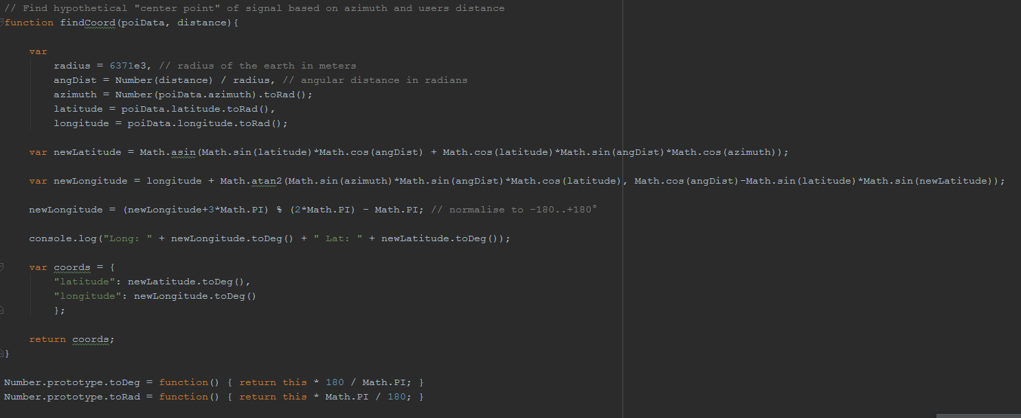

### Radar.js

“radar.js” is a simple script which handles the creation and animation of the radar which can be seen in the top left-hand side of the screen.

## Backend

In order to provide a useful service for ISPs I have added a simple GUI which can be used to input the location and properties of transmitting antennas. The page itself is written in HTML and Javascript and interacts with a MySQL database using PHP.

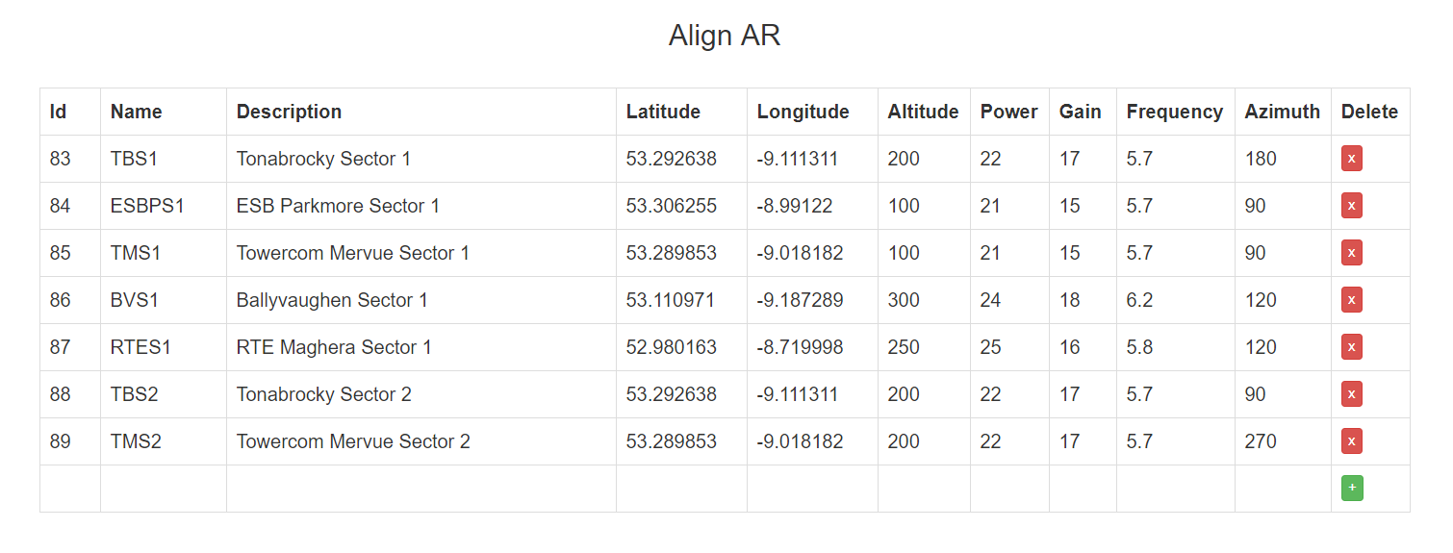

As can be seen in fig.xx above, this GUI consists of a simple “live table” which allows the user to view, edit and add antenna information conveniently.

Each interaction with the table is parsed into a MySQL query and sent over the wire to a database which is being hosted on one of the danu servers. In addition to this, each time the table is edited and the results sent to the database, a “select” query is used to retrieve the entire contents of the database which is then piped into a json file which is also stored on one of the danu servers. From here, the Android application is able to read the contents of the file and create the appropriate geo-objects as explained above.

In order to provide some level of authentication to this backend, I have added the Google login API, which allows a user to authenticate with their Google account credentials. This adds a convenient login method for a user and also allows me to keep track of who has logged in and at what time they have logged, thus enabling me to keep track of the changes a particular user has made.

\*\*\* PICTURE OF LOGIN WHEN IT LOOKS BETTER\*\*\*\*

# Testing & Evaluation

## Testing

I have extensively tested this application in the areas of performance, accuracy and usability. The following is a brief summary of the procedure performed and the results obtained in each of these categories:

### Performance

In order to test the performance of this application I installed it on 2 devices. The first device being a LTE Axion 7 mini smartphone running Android version 6.0.1 and the second being a Lenovo TB-8504F tablet running Android version 7.1.1. To test the performance of the application on each of these, I downloaded Sytem Panel 2 (SystemPanel2, 2018) on both devices, killed all unnecessary processes on each device and performed a typical use-case in the application for approximately 5 minutes at a time, occasionally over an eight hour period. The following are the results obtained:

\*\*\*\* TEST RESULTS PERFORMANCE \*\*\*\*\*

### Accuracy

In measuring the accuracy of this system, there are two primary concerns: The accuracy of the markers representing antenna locations and the accuracy of the link budget analysis used to determine the estimate received power.

To test the accuracy of the markers representing antenna locations, it is important to note whether or not the distance which the application presents to the user is accurate and also whether or not the markers are indeed, directing the user in the correct direction. To test the distance, I simply compared the distance presented in the app with the distance calculated my google maps. To test the direction, I inputted some fictitious antenna locations which were actually locations of easily visible landmarks around my location. I was then able to easily compare the direction the markers suggested with the visible landmark. It is worth nothing that while this test proved that the markers are accurate to a certain degree, to properly test this, I would need to use the application to align an antenna and then use a spectrum analyser to measure the received signal.

\*\*\*TEST RESULTS LOCATION ACCURACY\*\*\*

Again, without access to a spectrum analyser it is hard to determine just how accurate the link budget analysis in this application is. However, using the excel sheet provided by Maxim integrated (Maxim, 2011) I have been able to compare the results presented in the application with those obtained by entering the same distance, frequency etc. into the excel sheet. This has provided me with confidence in my link budget analysis as Maxim Integrated, being a fortune 1000 company specialising in this area, can be considered a reliable source.

\*\*\* TEST RESULTS LINK BUDGET ANALYSIS\*\*\*

### Usability

The final aspect of the application which I tested is its usability. As usability is largely subjective, I concluded that the most appropriate way to test the application’s usability was to get a number of people to use the application whilst following relatively vague instructions and then fill out a survey afterwards. To do this, I gave the following instructions:

1. Open the app, and enter a gain of 15 dBi for the “receiving antenna” you are aligning
2. Locate the marker labelled TBS1, then read out its expected power
3. Locate the marker labelled TMS1, then read out its estimated angle
4. Locate the same marker in the map view
5. Finally, filter out markers which are further away so that only 5 markers are being displayed

I then asked each user to rate, on a scale of 1-5 with 5 being completely true and 1 being completely false, how true they felt each statement was after using the application. These statements were:

1. I entered the gain value with little, to no hassle.
2. Locating an AR marker was simple and intuitive.
3. Finding the signal strength of this marker was also simple and intuitive
4. I refreshed the screen with little to no effort
5. Locating a marker in the map view was simple and intuitive
6. Finding and using the filtering function required minimal navigation and effort

The following are the results of this survey, as tested on 5 of my classmates:

Total Mean = 24.8 Total Std Deviation = 1.47

## Evaluation

This evaluation is divided into two sections:

* Evaluation of test results
* Evaluation of functionality provided

## Evaluation of test results

### Performance

### Accuracy

### Usability

#### 1. The application should be compatible with all android devices where a recent version of android is installed

Align AR has been built with Android SDK version 15 (Android 4.0.3, 4.0.4) as its minimum compatible version and has been extensively tested with Android SDK version 26 (Android 8.0). The app has been tested on several different versions of Android ranging from Android 5.0 up to the new Android 8.1 and performs well on all. The app has also been tested on a range of different devices including both new and old Android phones and tables and has not experienced any major issues with performance or with the GUI.

#### 2. The application should have read-only access to a database containing the following information:

#### a. The GPS co-ordinates of relevant microwave broadband transmitters

#### b. The effective isotropic radiated power of these transmitters

This requirement makes up a key part of the functionality of Align AR. As has been described in the implementation section above, in order to draw each marker on the screen and calculate the necessary link budget, a json file is read from a secure server, which in turn, gathers its information from a MySQL database. The access which the app has to this json file is strictly read-only and as the app only interacts with the json file and not the database itself a possible security hole is avoided.

#### 3. The application should be able to use this data to calculate the necessary link budget

This requirement has also been completed and somewhat extended as the app also offers the user the opportunity to input not just the receiving antenna gain value, but also the connection loss and cable loss if they so wish. This offers a higher level of accuracy for the user.

#### 4. Using the device’s camera, the application should display markers on the screen indicating the location of the transmitting antennas

Again, this requirement makes up one of the core functionalities of the app and is also a requirement which I have expanded on, as will be explained further below.

#### 5. To help with the alignment of the antenna, the application should provide visual and/or audio cues to the user indicating the best vertical and horizontal alignment and the expected signal strength when aligned

The markers on the screen indicate the position of each transmitting antenna in both the horizontal and vertical axis, this enables the user to align the antenna visually before viewing the antenna details overlay which tells the user more about the transmitting antenna’s exact position and suggests a suitable elevation angle for the receiving antenna

## Auxiliary Requirements

During the course or this project, my supervisor and I agreed upon a number of auxiliary requirements which are not set out in the project definition document. My evaluation of the project deliverable’s implementation of these requirements is as follows:

## 

#### A backend should be provided so that in a real-world scenario, ISPs can easily add, edit and delete antenna details on the fly.

Originally, the location and properties of each antenna was stored locally on the user’s device. This was convenient for development purposes but did not make the app very user friendly as to edit the details of any antenna involved manually editing a json file on a user’s device. To combat this, I have developed a backend (described above in implementation section) which authenticates a user and allows him/her to easily manage their database of antenna locations and properties. I’m very pleased with how this turned out as I believe it be extremely intuitive and user-friendly.

#### The application should be able to filter out sectors of a given mast so that only the appropriate antennas are displayed, taking into consideration the azimuth of each antenna and the user’s location.

This feature is important when taking into account how the app may be used in a real-world scenario. Typically, an ISP will have a number of antennas located on the one mast. This is because each of the antennas must send a signal which will travel a considerable distance and thus, must be highly directional. (REF: Reference about highly directional antennas). This presents a problem when attempting to display markers for each of these antennas as the markers will appear on top of each other. Also, It is also pointless to display information about an antenna which is not facing our user. It is because of these reasons that my supervisor and I decided to include a sector filter feature. This feature has been tested as described below (in testing section) and I am happy with its performance although I do feel that as a possible improvement, the algorithm used to filter out unwanted antennas could be improved. Currently, if the centre of the beam area of an antenna is closer to the user than the centre of the beam area of any other antenna on the same mast, then only that antenna’s marker will be displayed. (REF: beam area definition).This is sufficient for filtering out any unwanted antennas and does not pose much of a problem as an ISP technician will presumable know whether or not a transmitting antenna is pointing in the right direction before attempting to install a receiver. However, an improvement on this would be to perform the appropriate calculations in order to model the transmitting signal’s azimuth and elevation pattern and thus determine whether or not it is possible for the user to receive a signal from the chosen antenna.

#### Functionality should be provided to filter the number of markers displayed on the screen based on the distance between the user and these markers

A common problem with geo-location augmented reality applications is the over-cluttering of markers on the screen. (REF: some reference about augmented reality cluttering). To avoid this problem, a common solution is to filter out unwanted markers using some property. In Align AR, I have provided a simple slider to the GUI which allows a user to select the number of markers they would like displayed on the screen. As the user moves the slider to the left, markers which are the greatest distance away are removed, thus leaving it easier for a user to view and select appropriate markers. As an ISP may have several antennas all over the country, I believe this is a very useful feature which, whilst relatively simple to implement, greatly improves a user’s experience within the app.

#### A “map view” should be added so that the location of each antenna can be easily viewed by a user

This feature is more of a “nice-to-have” rather than a necessity, however, it does allow the user to view both a map and satellite view of their surrounding areas which, in turn, allows them to verify the location of each antenna to ensure that the markers, possibly inputted to the system by someone else, represent the true locations of the antennas.

#### C:\Users\cornwall\Downloads\30070191_2369890523037073_301318838_o.jpg C:\Users\cornwall\Downloads\29995969_2369890326370426_1111724887_o.jpg

#### C:\Users\cornwall\Downloads\29995588_2369890466370412_505579613_o.jpg C:\Users\cornwall\Downloads\30070743_2369890323037093_1253483617_o.jpg

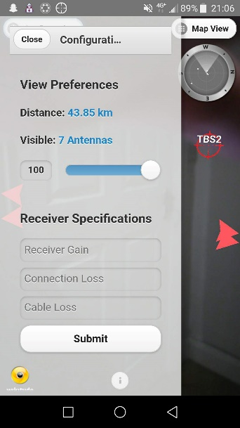

# Conclusion

To conclude,

References

**Growth of wireless**

# Wireless Infrastructure Market Size, Share & Trends Analysis Report By Technology (Macrocell RAN, Small Cells, RRH, DAS, Cloud RAN, Carrier Wi-Fi, Mobile Core, Backhaul), And Segment Forecasts, 2018 – 2025

**Sat finder3d**

<https://play.google.com/store/apps/details?id=us.kvasha.satfinder3dlite&hl=en>

**Java**

<https://docs.oracle.com/javase/8/docs/technotes/guides/language/index.html>

**PHP**

http://php.net/manual/en/intro-whatis.php

**Wikitude**

https://www.wikitude.com/

(<http://dbis.eprints.uni-ulm.de/1522/1/PRY_JUS_17.pdf>)

## The AREA Framework for Location-Based Smart Mobile Augmented Reality Applications - Rüdiger Pryss\*, Philip Geiger, Marc Schickler, Johannes Schobel, Manfred Reichert

## Navigation in Augmented Reality : AN EXPERIMENTAL STUDY COMPARING NAVIGATION IN AUGMENTED REALITY AGAINST ONLINE STANDARDIZED MAPS - SARAH BERNELIND

(google scholar)

https://www.maximintegrated.com/en/app-notes/index.mvp/id/5142

https://en.wikipedia.org/w/index.php?title=Maxim\_Integrated&dir=prev&action=history

# Works Cited

**There are no sources in the current document.**